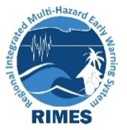



Development of Local Flood Early Warning and Dissemination System
PROVATi3 Project-DDM Component
July 2023

Monthly Report
Regional Integrated Multi-Hazard Early Warning System (RIMES)
Section A
Progress Summary
- Quarterly Progress (April-June) Sharing Meeting of PROVATi3 Project-DDM Component
- DMC training on Flood risk and Early warning system at Kurigram
- Training on DMC portal
- Land Gauge Consultation at Gaibandha and Kurigram
- Meeting on receiving server service from BCC
- Union-level vulnerability map generation
Section B
Activity 1. Quarterly Progress (April-June) Sharing Meeting of PROVATi3 Project-DDM Component
Progress
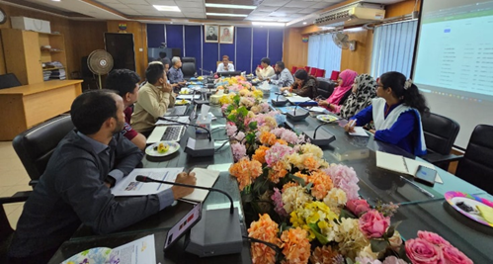
Quarterly progress sharing meeting was held at DDM on 11 July 2023 with DDM, LGED, and RIMES professionals. The meeting took place to identify and discuss project progress and the issues, emerged as challenges in various activities of “Development of Local Flood Early Warning and Dissemination System” during the last 3 months (April, May and June). Md. Mizanur Rahman, Director General of DDM chaired the meeting. Netai Chandra Dey Sarker, Director (MIM) and Project Coordinator of PROVATi3 Project-DDM component, DPC (GIS & RM), Team leader, Program Manager, LGED representative and other RIMES personnel joined the meeting. In the meeting, GIS specialist discussed the activities of previous months, and then different project related issues such development of voice message portal, training on DMC portal and flood early warning, land gauge installation etc were discussed in detail. Future activities that need to be accomplished by the next quarter were also discussed in the meeting.
Activity 2. DMC training on Flood risk and Early warning system at Kurigram
Progress
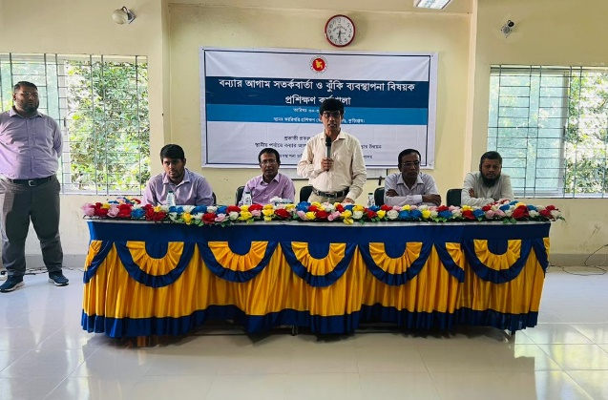
Two training have been held in Kurigram on two consecutive days. One training was arranged for Rajarhat upazila DMC members on 30th July 2023. And another one was held on 31th July 2023 for Upazila and union level DMC members of Kurigram Sadar upazila. Honourable DG MD. Mizanur Rahman was the chief guest of the training and inaugurated the training session via online platform. The program was chaired by Netai Chandra Dey Sarkar, Director (MIM) and Project Coordinator of PROVATi³ project-DDM part. The training sessions were continued with upazila-level DMC members as participants including UNO, DRRO, UP chairman of respective upazilas and other members of union and upazila level DMC. DDM, BWDB and RIMES representatives serve there as trainers in different sessions. DMC members are trained up on basic disaster terminologies, flood early warning and their roles and responsibilities during disasters.
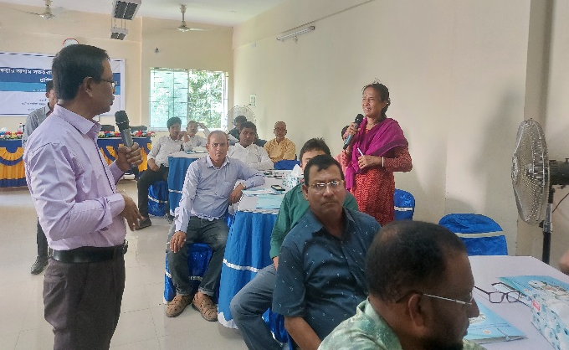
Activity 3. Training on DMC portal
Progress
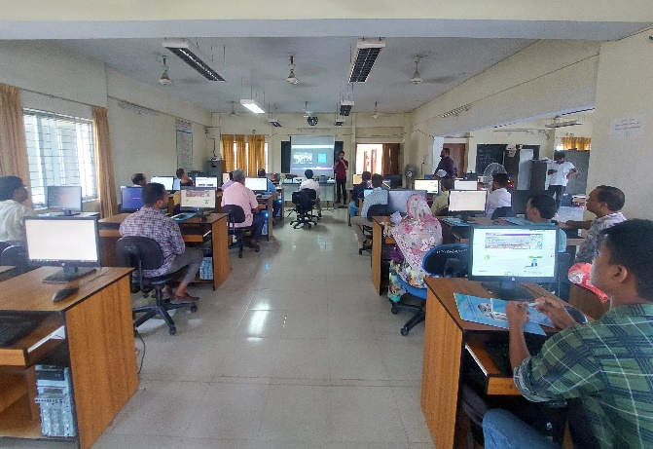
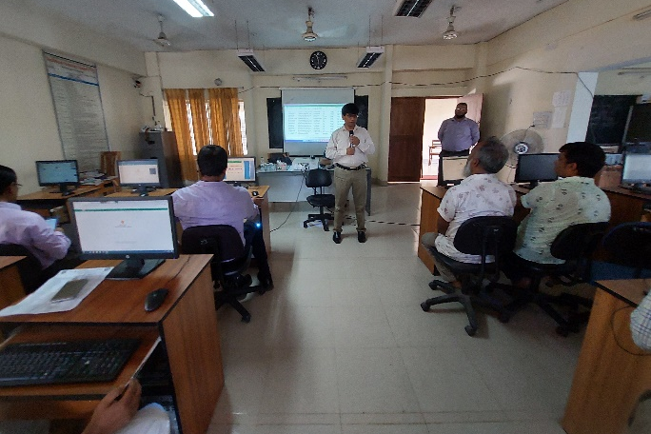
DMC database was developed under this project with the technical support of RIMES. Initially, it contains all the DMC members information of the project area. These information will further be updated by respective DMC by themselves which can be used in time of emergency. For this reason, representatives of each DMC members need to be trained on how to search for DMC members list; update, edit or delete information, upload DMC meeting resolution or additional things of the portal. 2 portal training held in Kurigram. One is for Rajarhat Upazila DMC representatives on 30th July 2023 and other one is for Kurigram Sadar DMC representatives on 31th July 2023. Rajarhat training session was inauguarated by Honorable DG of DDM and Chief guest of the program, MD Mijanur Rahman via online platform. Both programs were chaired by Netai Chandra Dey Sarkar, Director (MIM) and Project Coordinator of the PROVATi³ project-DDM component. Mobinur Rahman, ICT specialist demonstrated the portal use. Participants of the training were UP secretary of respective unions, PIOs of respective upazilas and their secretaries, and UDC entrepreneur. Additional participants for Kurigram Sadar was DRRO and the secretary of the DRROs office, Paura Nirbahi Officer (PNO) and secretary of the PNOs office.
Activity 4. Land Gauge Consultation
Progress
To validate the accuracy of inundation mapping, land gauge reading of the water level is a must. Field facilitators have been visiting each union parishad office for the last few months and discussing potentially suitable spots for installing land gauges. A recent visit has been made by the GIS specialist and the Regional Coordinator of the project and consultation in 4 unions of Kurigram and Gaibandha districts. For every union, at least three locations are being selected upon UDMC suggestion. Overall consultation progress is as follows
District | Consultation covered (No of Unions) | Consultation remaining (No of Unions) | Existing gauge identified (No of Gauges)
Gaibandha | 11 | 0 | 7
Kurigram | 25 | 1 | 11
Jamalpur | 18 | 0 | 15
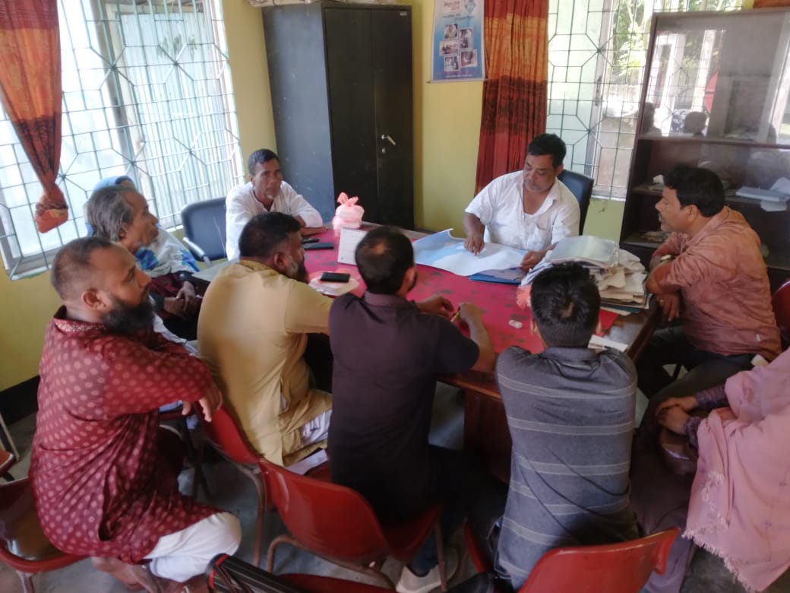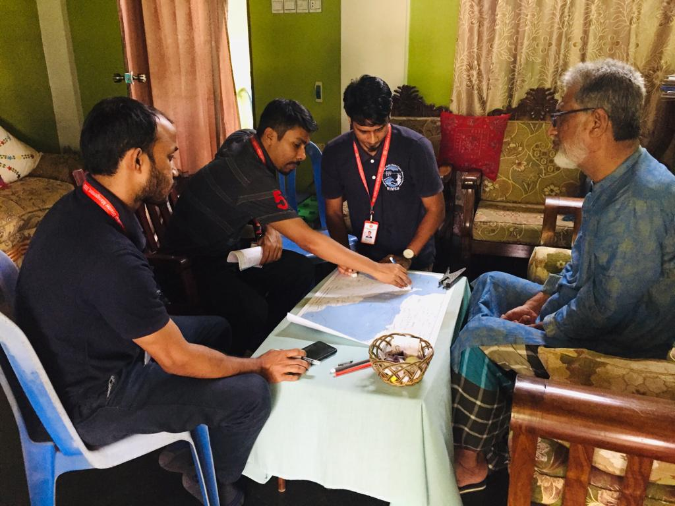
Activity 5. Meeting on receiving server service from BCC
Progress
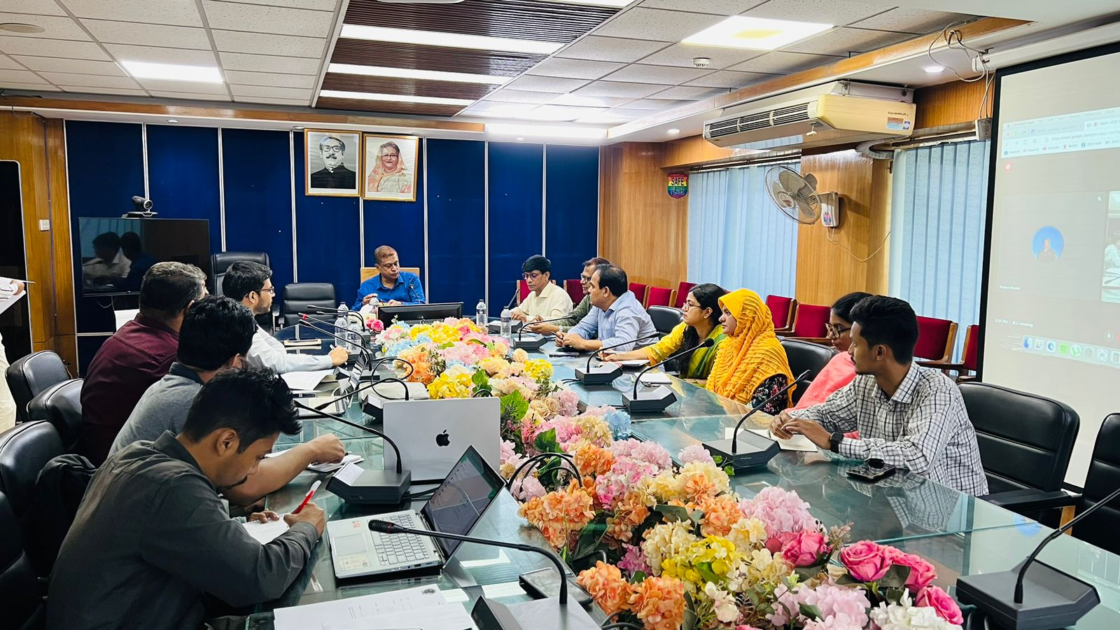
To develop a voice message portal, a server system is required through which voice messages will be delivered to field level beneficiaries. A meeting was called with BCC on 25th July 2023 to get ideas if they have dedicated server for rent. Md Mijanur Rahman, Director General, Department of Disaster Management chaired the meeting. The hydrologic System developer of the project shared the system requirement and server specification with the BCC representative. BCC representative informed that they had cloud platform to provide such services. Still final decision on receiving such services will be taken after another internal discussion of BCC based on project requirements.
Activity 6. Union level vulnerability map generation
Progress
Though project area located near the major rivers, the vulnerability of individual upazilas and unions are not the same. They depend on various physical, social, environmental and economic indicators. To understand the localized risk level vulnerability score have been calculated at union level for Jamalpur District considering sensitivity and adaptive capacity of each union. And based on those scores, upazila level vulnerability map have been produced comparing unions of that respective upazila.
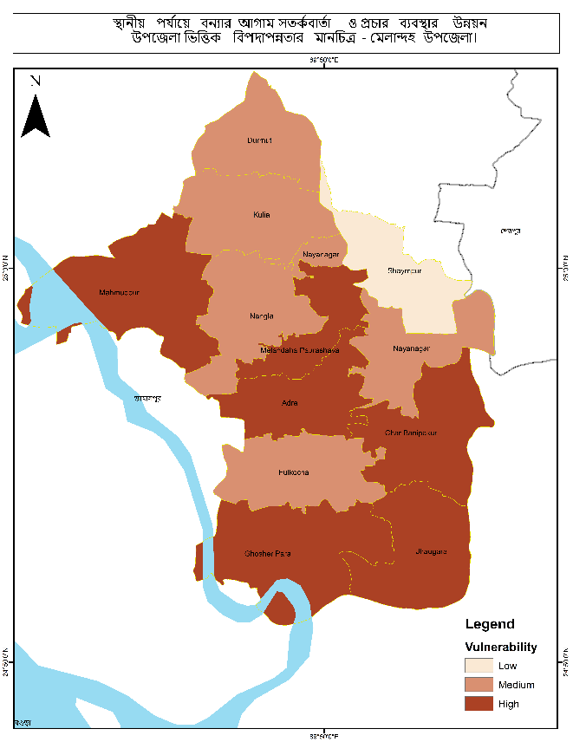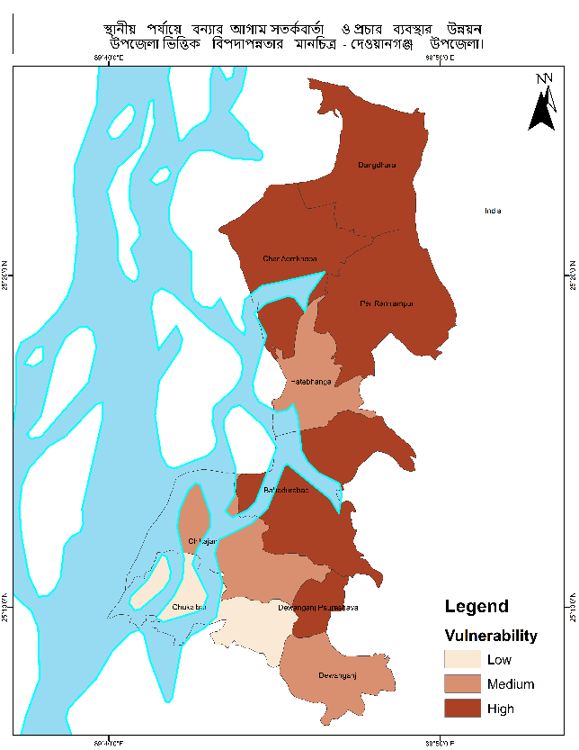
Section C
Challenges & Overcome Strategy
- Topographic survey remained paused from July as monsoon has started and the water level are changing which will cause error in DEM data.
Section D
Work plan for August Month 2023
- Conducting of training on flood early waring and risk management for DMCs in project area
- Arrange a field level demonstration on DMC database
- Rest of the land gauge consultation would be completed.
- Union level Vulnerability map will be prepared for Kurigram and Gaibandha district

Section E
Budgetary Reflection
N/A

